- Choosing a Topic: When starting new research, what is the single most important factor that influences your choice of topic (e.g., available funding, personal passion/curiosity, or direct alignment with a societal need/SDG)?
I usually choose a topic that is aligned with my primary research interest (managerial accounting), the funding and alignment with specific agenda items would be secondary consideration.
- Choosing a Collaborator (Skills): Do you prefer a partner who has a very similar research expertise to yours (to deepen the work), or one who has a complementary skill set (to broaden the scope)?
I usually choose collaborators based on similar interest in topic but complementary skill set in tackling different methods, data skills, etc.
- Key Metrics: If our dashboard were to give you a "Compatibility Score" (from 1-100) for a potential partner, what three specific metrics or pieces of information would you want that score to be based on to make it truly useful for you?
Research topic (...),
Method (survey, experiment, archival, qualitative,),
Career stage (before tenure, after tenure, doctoral student)

Goal: Clearly present the two distinct paths (Faculty vs. Student/Donor) for the judges.
Action | Visual Asset | Details to Include
A. "Join Us!" Section | Full-slide visual mockup. | Headline: "Connect. Collaborate. Impact." (Use Illinois Blue/Orange).
B. Three CTAs | Highlight the three calls to action as large, distinct buttons. | 1. Find a Collaborator (Faculty focus) 2. Find Opportunities (Student focus) 3. Sponsor a Priority (Donor focus)

Door / CTA | Who Clicks It | What They Are Looking For
Find a Collaborator | Faculty/Researchers | I have a project; who is the best co-author for me?
Find Opportunities | Students/Junior Faculty | I have skills; what project needs me?
Sponsor a Priority | Partners & Donors | I have money; where can I invest it to make the biggest impact?

2. The Faculty Path: The Collaboration Compatibility Score (CCS)
This is the core innovation because it directly uses Professor Fei's expert opinion to provide a personalized recommendation.

What is the CCS?
The CCS is a single number (out of 100) that tells a faculty member how strong a partnership would be with another person.
- Goal: To move beyond just sharing a department to pairing people who have the right mix of topic focus AND skill sets.
- The Matchmaker's Formula: We use Professor Fei's criteria to build the formula, giving the most importance (weight) to what she said matters most.

Criteria | Weight | The Professor Said... | How the AI Calculates It (The 'Grounded' Part)
Topic Match | 45% (Highest) | "Research interest is the first priority." | The system uses the FAISS Vector Database (a high-tech, digital library) to find researchers whose keywords and concepts are almost identical to yours.
Method Match | 40% (Very High) | "I look for a complementary skill set (e.g., if I do theory, they do data)." | The AI rewards dissimilarity. If you use 'Archival' data and your partner uses 'Survey' methods, the score gets a perfect 100 on this part, creating a strong interdisciplinary team.
Career Stage | 15% | "Career stage matters (Post-Tenure, Doctoral)." | The AI looks for strategic fits, like pairing a seasoned Post-Tenure mentor with a rising Doctoral student.

The Two Must-Have Features for Faculty:

A. Proactive Search Results
Instead of a basic list, the faculty member immediately sees the recommended partner at the top:
- The Result: Dr. Garlappi, Lorenzo - 94/100
- The Action: This high score tells the faculty member: "Stop searching! This person is your best possible collaborator based on your professional needs."

B. The Transparent AI Breakdown (The Trust Builder)
This is the proof slide. When the faculty member clicks the "Why this score?" CTA, a modal pops up showing the reason for the high score:
Visual Element | Data Point (The 94/100 Breakdown) | Why It Builds Trust
Topic Match | 95/100 | "We agree on the topic (Behavioral Accounting)."
Method Match | 100/100 | "We have perfect complementary skills (Archival + Survey)."
Career Stage | 90/100 | "This is a beneficial mentorship match."
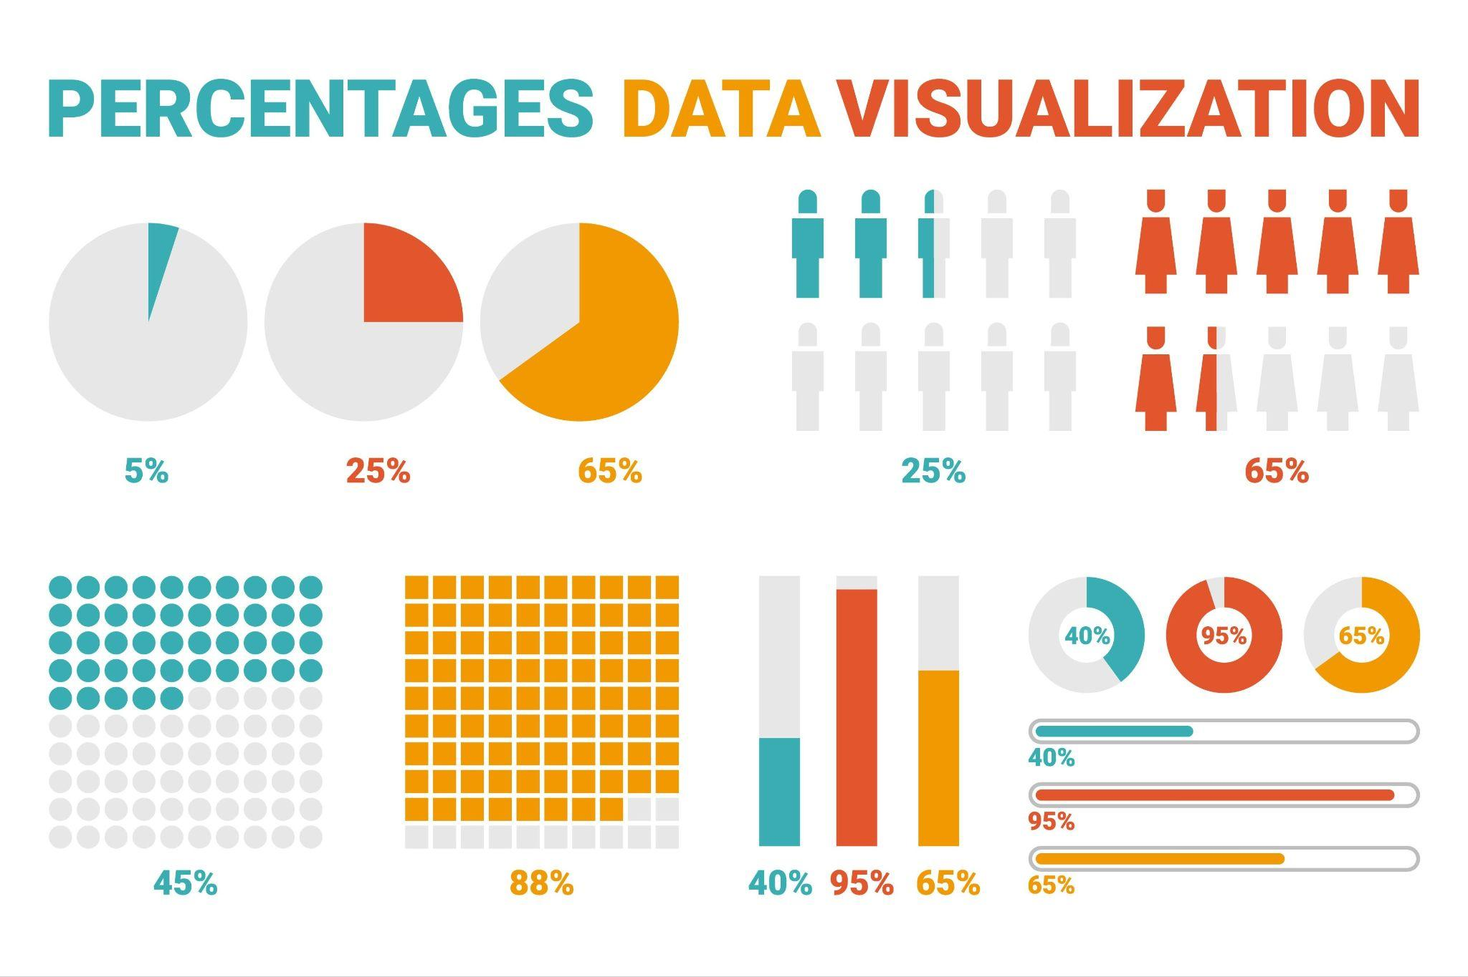

3. The Vision: Network Graph Integration
The Network Graph is how we zoom out and show university leadership the bigger picture.
- What it is: It's a map where every researcher is a dot (node) and the lines connecting them are collaborations (edges).
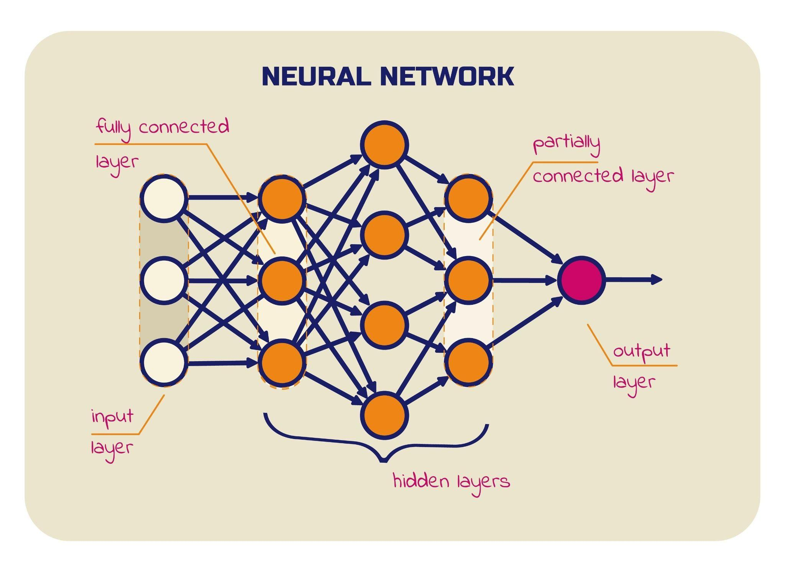How the CCS helps: The Compatibility Score determines how thick and bright those connecting lines are.
- Thick, Bright Line: CCS is high (94/100). This is a strong, viable team opportunity.
- Thin, Dotted Line: CCS is low.
Goal: Leadership can look at the map and instantly see the brightest, thickest lines and know exactly where to invest strategic funding to create powerful interdisciplinary centers.

4. The Student and Donor Paths (Other Components)
These are simpler flows that use different scores:

Audience | What They See | What it Does
Students | Research Opportunity Board | Projects ranked by Opportunity Match Score (based on skills and SDG interest), showing them exactly where to apply.
Partners & Donors | Funding Needs Board | An interactive chart showing SDGs with low research coverage (gaps). This tells donors: "Your money is most needed here for maximum impact."

CTA Text | Target Audience | Purpose (What it does) | Strategic Value for Competition
1. Find a Collaborator | Faculty / Researchers | Directs the user to the CCS Ranking feature, where the system proactively suggests partners based on Topic, Method, and Career Stage. | The Core Innovation (Pillar 2). Solves the high-stakes problem of finding the right partner.
2. Find Opportunities | Students / Junior Faculty | Directs the user to the Research Opportunity Board, which lists existing projects ranked by the Opportunity Match Score. | The Recruitment Tool. Solves the student's problem of finding a relevant project.
3. Sponsor a Priority | Partners & Donors | Directs the user to the Funding Needs Board, which highlights specific research gaps and priority projects that require funding. | The Revenue Tool. Solves the university's problem of securing strategic funding (addressed in Section 4.B of your plan).

